**Practical -04**

Implementing Link and Form in HTML

1. Design a simple webpage about your college. Create another webpage named address.html containing the college address. Give links from college page to address.html.

*Main_Page.html*

<html>

<head>

<title>college</title>

</head>

<body>

<h1>DHARMSIGH DESAI UNIVARSITY</h1>

<h2>

Dharmsinh Desai Institute of Technology was founded in 1968 by Dharmsinh

Dadubhai Desai, who then was a member of Parliament, as an institution of

higher learning in the field of Engineering and Technology. It achieved

autonomous status under Gujarat University in 1991 status in June 2000.

</h2>

<h3>Address of DDU</h3>

<a href="address.html">click here...</a>

</body>

</html>

*Address.html*

<!DOCTYPE html>

<html lang="en">

<head>

<meta charset="UTF-8">

<meta name="viewport" content="width=device-width, initial-scale=1.0">

<title>college website</title>

</head>

<body>

<h1>DHARMSIGH DESAI UNIVARSITY</h1>

<h3>Address of DDU</h3>

<h5>

Dharmsign Desai Univarsity ,<br>

near cenal , college road ,

<br>Nadiad

</h5>

</div>

</body>

</html>

***OUTPUT :-***

Main_page.html

Address.html

Q2. Design an attractive webpage about India. Provide details about the Indian freedom movement at the bottom of the webpage. Also create another webpage containing the list of states in India, named „states.html‟. Create two links in the main webpage – one to link to the bottom of the webpage where details about freedom movement is given and another to the webpage „states.html‟.

*Main_page.html*

<html>

<head>

<title>Indian freedom movement</title>

</head>

<body>

<h1>INDIAN FREEDOM MOVEMENT</h1>

<p>

The Indian freedom movements started in 1857 with the revolt of 1857. The

first war of independence against British rule. It began in Meerut against

the East India Company. The indian independence movement was a series of

historic event with the ultimate aim of ending british rule in india also

known as british Raj. it lasted until 1947.

</p>

<footer>

<h3>to more about Indian freedom movement</h3>

<a href="freedom.html">click here</a>

<h3>lists of state</h3>

<a href="state.html">state lists</a>

</footer>

</body>

</html>

*state.html*

<!DOCTYPE html>

<html lang="en">

<head>

<meta charset="UTF-8">

<meta name="viewport" content="width=device-width, initial-scale=1.0">

<title>state lists</title>

</head>

<body>

<h1> Lists of state</h1>

<ul>

<li>Gujrat</li>

<li>rajsthan</li>

<li>maharastra</li>

<li>dilhi</li>

<li>tamil nadu</li>

<li>keral</li>

<li>bengal</li>

<li>Bihar</li>

</ul>

</body>

</html>

*Freedom.html*

<!DOCTYPE html>

<html lang="en">

<head>

<meta charset="UTF-8" />

<meta name="viewport" content="width=device-width, initial-scale=1.0" />

<title>more info about freedom movement</title>

</head>

<body>

<h1>more Information About freedom movement</h1>

<p>

The Indian independence movement was in constant ideological evolution.

Essentially anti-colonial, it was supplemented by visions of independent,

economic development with a secular, democratic, republican, and

civil-libertarian political structure. After the 1930s, the movement took

on a strong socialist orientation. It culminated in the Indian

Independence Act 1947, which ended Crown suzerainty and partitioned

British Raj into Dominion of India and Dominion of Pakistan. India

remained a Crown Dominion until 26 January 1950, when the Constitution of

India established the Republic of India. Pakistan remained a dominion

until 1956 when it adopted its first constitution. In 1971, East Pakistan

declared its own independence as Bangladesh.

</p>

</body>

</html>

***OUTPUT :-***

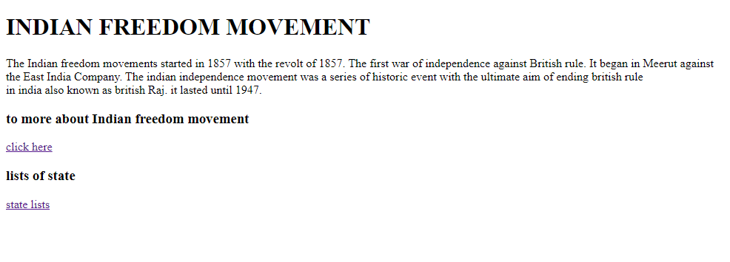

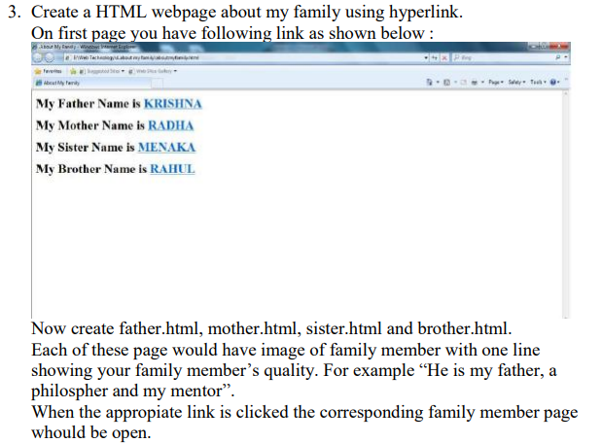

*Main_Page.html*

<!DOCTYPE html>

<html lang="en">

<head>

<title>family information</title>

</head>

<body>

<h1>My Father Name is <a href="father.html">RajivBhai</a></h1>

<h1>My Mother Name is <a href="mother.html">ManishaBen</a></h1>

<h1>My Brother Name is <a href="brother.html">Varshil</a></h1>

</body>

</html>

*Father.html*

<!DOCTYPE html>

<html lang="en">

<head>

<title>father detail</title>

</head>

<body>

<h1>Father Details :</h1>

<img src="f.jpeg" />

<h2>Name : RajivBhai G. Lathiya</h2>

<h3>He is a Loco-Pilot In INDIAN RAILWAY</h3>

</body>

</html>

*Mother.html*

<!DOCTYPE html>

<html lang="en">

<head>

<title>details</title>

</head>

<body>

<h1>Mother Details :</h1>

<img src="m.jpg" />

<h3>Name : ManishaBen R. Lathiya</h3>

<h3>My mother is a House Wife </h3>

</body>

</html>

*Brother.html*

<!DOCTYPE html>

<html lang="en">

<head> <title>details</title> </head>

<body>

<h1>Brother Details :</h1>

<img src="b.png" />

<h3>Name : Varshil R. Lathiya</h3>

<h3>He is a very JoyFul Person</h3>

</body> </html>

***OUTPUT :-***

4. Create a web page with an appropriate image towards the left hand side of the page, when user clicks on the image another web page should open.

<!DOCTYPE html>

<html lang="en">

<head> <title>document</title> </head>

<body>

<h1>Example of Image Nevigation</h1>

<a href="https:www.google.com">

<img src="try.jpg" width="400px" height="600px" /> </a>

</body> </html>

 ***OUTPUT :-***

5. Write a HTML program for demonstrating Hyperlinks. Navigation within the page

<!DOCTYPE html>

<html>

<head> <title>Navigation Demo</title> </head>

<body>

<h1>Navigation Demo</h1>

<h2>Contents:</h2>

<ul>

<li><a href="#section1" onclick="document.bgColor='red'">Section 1</a></li>

<li> <a href="#section2" onclick="document.bgColor='blue'">Section 2</a> </li>

<li><a href="#section3" onclick="document.bgColor='yellow'">Section 3</a></li>

</ul>

<div id="section1">

<h2>Section 1</h2>

<p>

This is the content of Section 1 Lorem ipsum dolor sit amet consectetu adipisicing elit. Reiciendis, dignissimos. Quod animi aperiam quaerat laboriosam illat laborum, quod facilis atque fugiat distinctio id anim dolor impedit eligendi dignissimos commodi, aspernatur architect voluptatibus sed ut consequatur.

</p>

</div>

<h2 id="section2">Section 2</h2>

<p>This is the content of Section 2.Lorem ipsum dolor sit amet consecteturadipisicing elit. Reiciendis, dignissimos. Quod animi aperiam quaerat laboriosam ipsam eum, nemo aliquid magnam ad exercitationem odio eiusinventore laudantium deleniti quos commodi delectus?Lorem ipsum dolor sitamet consectetur adipisicing elit. Sit suscipit odio doloremque quide </p>

<h2 id="section3">Section 3</h2>

<p>This is the content of Section 3.Lorem ipsum dolor sit amet consectetu adipisicing elit. Reiciendis, dignissimos. Quod animi aperiam quaerat laboriosam ipsam eum, nemo aliquid magnam ad exercitationem odio eius inventore laudantium deleniti quos commodi delectus?Lorem ipsum dolor sit amet consectetur adipisicing elit. Sit suscipit

</p>

<p><a href="#top">Back to top</a></p>

</body>

</html>

***OUTPUT :-***

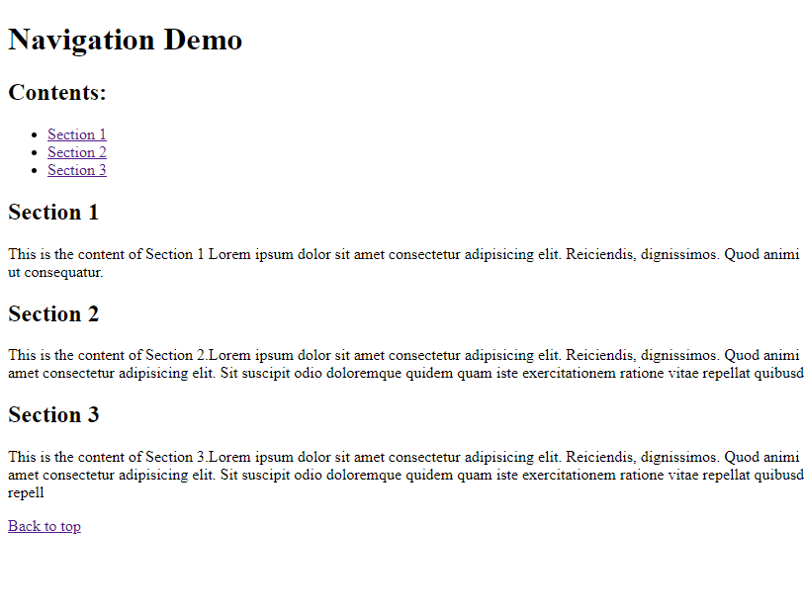

6. Write a HTML program to demonstrate all target attribute of tag.[ for example target : _self, _blank, _top, _parent, iframe]

<html>

<head>

<title>document</title>

</head>

<body>

<h1>Target Attribute</h1>

<h2>_self - Open in the same frame</h2>

<p><a href="p1.html" target="_self">program1</a></p>

<h2>_blank - Open in a new tab or window</h2>

<p><a href="p2.html" target="_blank">program2</a></p>

<h2>_top - Open in the top-level frame</h2>

<p><a href="p3.html" target="_top">program3</a></p>

<h2>_parent - Open in the parent frame</h2>

<p><a href="p4.html" target="_parent">program 4</a></p>

<h2>iframe - Open in an inline frame</h2>

<iframe src="p5.html" width="400" height="300"></iframe>

<p><a href="p5.html" target="iframe">visit a program iframe above</a></p>

</body>

</html>

***OUTPUT :-***

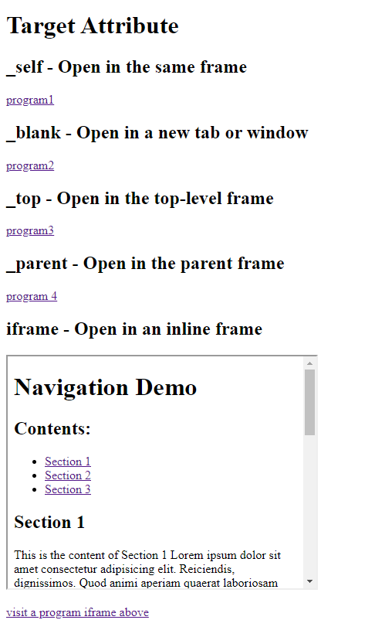

<html>

<head>

<title>Link List</title>

</head>

<body>

<h2>HTML List: Ordered, Unordered & Definition List</h2>

<hr />

<p>Following is the list of proposed student activities like:</p>

<ol>

<li>Develop programs related with unit vice in computer laboratory.</li>

<li>Develop any module of to be useful in real life application</li>

<li>Multimedia presentation of module developed by students.</li>

</ol><hr />

<p>List of software/learning website</p>

<ul><li><u>ASPTutorialW3Schools</u><br/><ahref="www.w3schools.com/asp">www.w3schools.com/asp</a></li>

<li><u>Classic ASP Tutorial &Articala -web wiz</u> <br /><a href="www.webwiz.co.uk-knowledgebase">www.webwiz.co.uk-knowledgebase</a>

/li>

<li><u>HTMLTutorial-W3Schools</u><br/><a href="www.w3schools.com/html">www.w3schools.com/html</a>

</li>

<li><u>CSS Tutorial </u> <br /><a href="www.csstutorial.net">www.csstutorial.net</a>

</li>

<li> <u>VBScript Tutorial - Tutorials Point </u> <br /><a

href="www.tutorialspoint.com/vbscript/index.htm">www.tutorialspoint.com/vbscript/index.htm</a>

</li>

<li><u>ADOTutorial-W3Schools</u><br/><ahref="www.w3schools.com/ADO/default.asp">www.w3schools.com/ADO/default.asp</a>

</li> </ul><hr />

<dl>

<dt>HTML</dt>

<dd>Hypertext markup language</dd>

</dl>

<dt>XML</dt>

<dd>Extensible Markup Language</dd>

</body>

</html>

***OUTPUT :-***

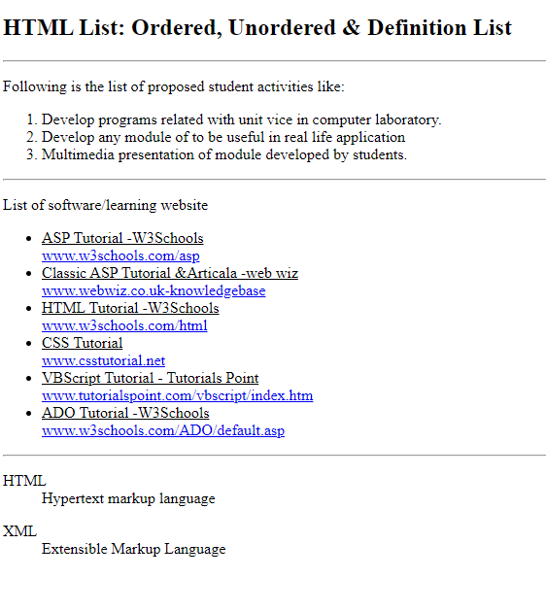

8. Consider that your school is hosting an inter-school IT fair. Design a form webpage that contains a form for accepting registrations. The form page should contain facility to enter school name, user name, password and a mobile phone number. It should also contain buttons for saving and clearing data entered.

<html>

<head> <title>IT Fair Compition</title> </head>

<body>

<h2>Student Registration</h2>

<form action="#" method="post">

School Name : <input type="text" name="sname" id="sname" /> <br>

User Name : <input type="text" name="username" id="username" /><br>

Password : <input type="password" name="password" id="password" /><br>

Mobile : <input type="number" maxlength="10" > <br><br>

<input type="submit" value="submit" />

<input type="reset" value="cancel" />

</form>

</body> </html>

***OUTPUT :-***

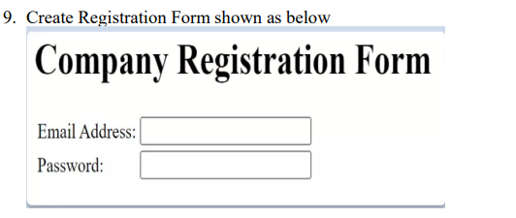

<!DOCTYPE html>

<html lang="en">

<head>

<meta charset="UTF-8" />

<meta name="viewport" content="width=device-width, initial-scale=1.0" />

<title>company Registration From</title>

</head>

<body>

<h1>Company Registration</h1>

<form action="#" method="post">

<table>

<tr>

<td><label for="email">email address : </label></td>

<td><input type="email" name="email" id="email" /></td>

</tr>

<tr>

<td><label for="password">Password : </label></td>

<td><input type="password" /></td>

</tr>

<tr>

<td>

<input type="submit" value="Submit" />

</td>

</tr>

</table>

</form>

</body>

</html>

***OUTPUT :-***

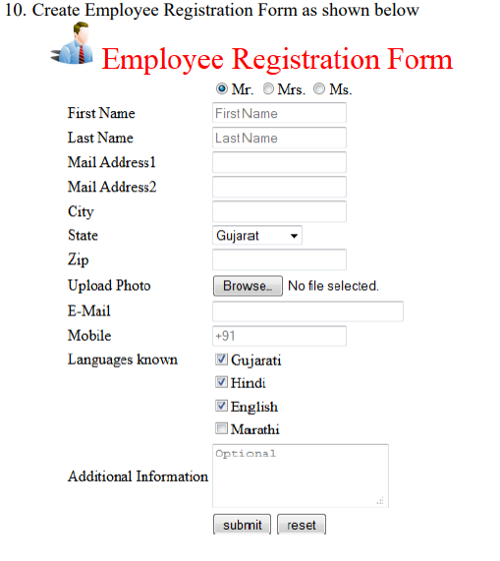

<!DOCTYPE html>

<html lang="en">

<head>

<meta charset="UTF-8">

<meta name="viewport" content="width=device-width, initial-scale=1.0">

<title>employee registration form</title>

</head>

<body>

<form action="#" method="post">

<table>

<tr>

<td><img src="man.png" alt="images" height="100px" width="100px"></td>

<td><h1 style="color: red;">Employee Registration Form</h1></td>

</tr>

<tr>

<td></td>

<td>

<input type="radio" name="label" id="label" value="Mr. " checked>Mr.

<input type="radio" name="label" id="label" value="Mrs.">Mrs.

<input type="radio" name="label" id="label" value="Ms.">Ms.

</td>

</tr>

<tr>

<td><label for="fname">First Name : </label></td>

<td><input type="text" name="name" id="name" placeholder="First name"></td>

</tr>

<tr>

<td><label for="lname">Last Name : </label></td>

<td><input type="text" name="lname" id="lname" placeholder="Last name"></td>

</tr>

<tr>

<td><label for="address1">Mail Address1 : </label></td>

<td><input type="text" name="address1" id="add1"></td>

</tr>

<tr>

<td><label for="address2">Mail Address2 : </label></td>

<td><input type="text" name="address2" id="add2"></td>

</tr>

<tr>

<td><label for="city">city</label></td>

<td><input type="text" name="city" id="city"></td>

</tr>

<tr>

<td><label for="state">State</label></td>

<td>

<select name="state" id="state">

<option value="gujrat">Gujrat</option>

<option value="bihar">Bihar</option>

<option value="maharastra">Maharastra</option>

<option value="assam">Assam</option>

<option value="delhi">Delhi</option>

<option value="bengal">Bengal</option>

</select>

</td>

</tr>

<tr>

<td><label for="zip">Zip : </label></td>

<td><input type="number" name="zip" id="zip"></td>

</tr>

<tr>

<td><label for="upload images">Upload Image : </label></td>

<td><input type="file" name="f1" id="f1"></td>

</tr>

<tr>

<td><label for="email">Email : </label></td>

<td><input type="email" name="email" id="email"></td>

</tr>

<tr>

<td><label for="mobile">Mobile : </label></td>

<td><input type="number" name="mobile" id="mobile" placeholder="+91"></td>

</tr>

<tr>

<td><label for="lang">Language Known : </label></td>

<td><input type="checkbox" name="ch1" id="ch1" value="gujrati">Gujrati <br>

<input type="checkbox" name="ch1" id="ch1" value="hindi">Hindi <br>

<input type="checkbox" name="ch1" id="ch1" value="english">English <br>

<input type="checkbox" name="ch1" id="ch1" value="marathi">Marathi <br></td>

</tr>

<tr>

<td><label for="add info">Additional Information : </label></td>

<td><textarea name="addinfo" placeholder="Optional" id="addinfo" cols="30" rows="10" >optional</textarea></td>

</tr>

<tr>

<td colspan="2">

<input type="submit" value="Submit">

<input type="reset" value="Reset">

</td>

</tr>

</table>

</form>

</body>

</html>

***OUTPUT :-***

